<https://www.guru99.com/python-tutorials.html>

## Characteristics of Python

* It provides rich data types and easier to read syntax than any other programming languages
* It is a platform independent scripted language with full access to operating system API's
* Compared to other programming languages, it allows more run-time flexibility
* It includes the basic text manipulation facilities of Perl and Awk
* A module in Python may have one or more classes and free functions
* Libraries in Pythons are cross-platform compatible with Linux, MacIntosh, and Windows
* For building large applications, Python can be compiled to byte-code
* Python supports functional and structured programming as well as OOP
* It supports interactive mode that allows interacting[Testing](https://www.guru99.com/software-testing.html)and debugging of snippets of code
* In Python, since there is no compilation step, editing, debugging and testing is fast.

**Python used for**

* Programming video games
* Artificial Intelligence algorithm
* Programming various scientific programs such as statistical models

Udemy

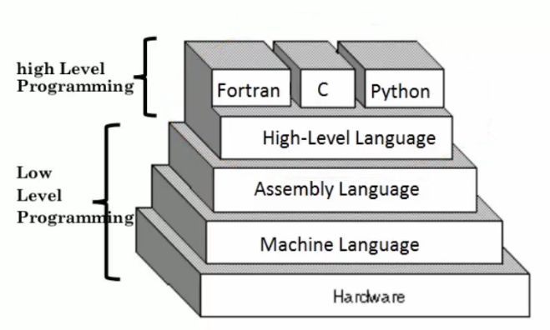

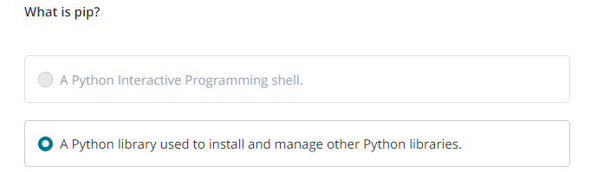







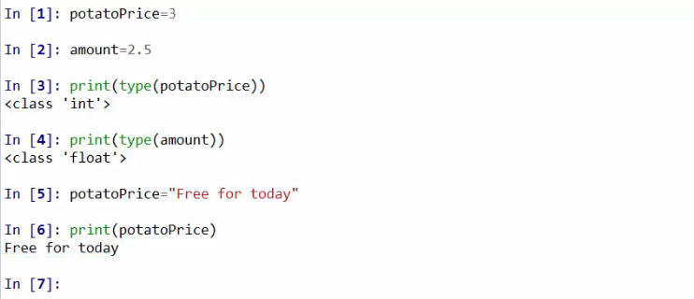

Comment starts with **“””** ends with **“”” (triple double quots)**

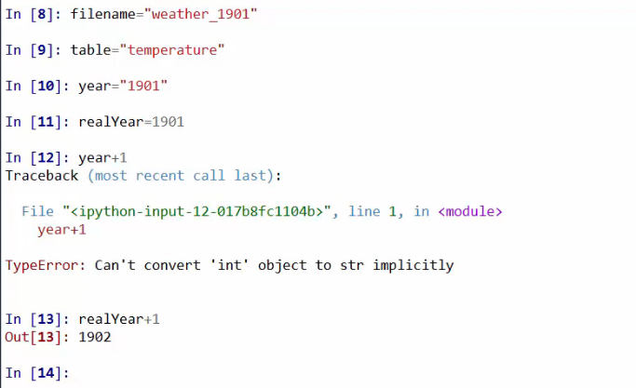

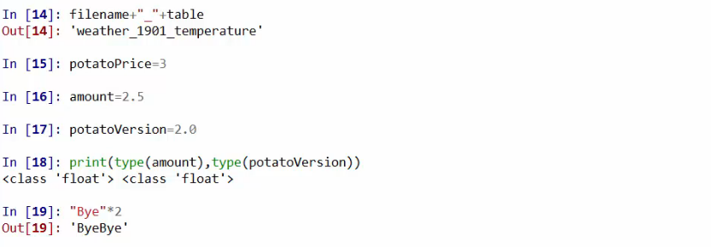

s="string"  
s1="string1"  
a=s+s1+1+s

TypeError: can only concatenate str (not "int") to str

Keep in mind that spaces before and after the assignment operator don't affect anything. Just do it your own way. For the sake of speed, I don't normally use spaces.

A = 2

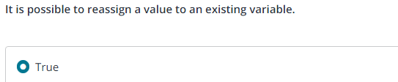

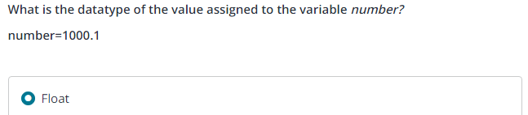

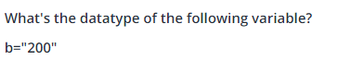

Even though the number 200 looks like an integer, it is indeed a string because it is enclosed in quotes. Everything enclosed in double or single quotes is a string in Python.

If else

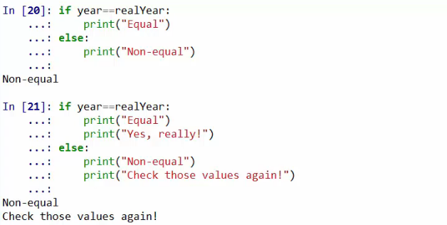

Functions

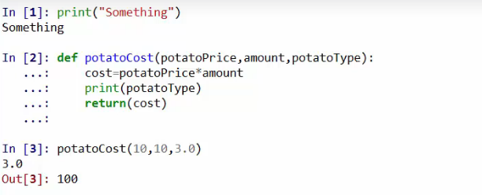

**Converting miles to KM**

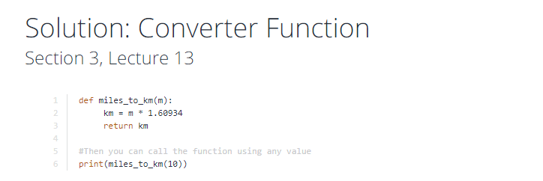

Calculate rectangle area

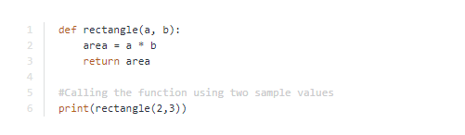

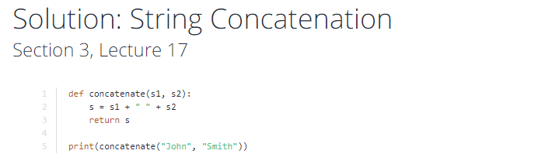

Sequences lists and tuples

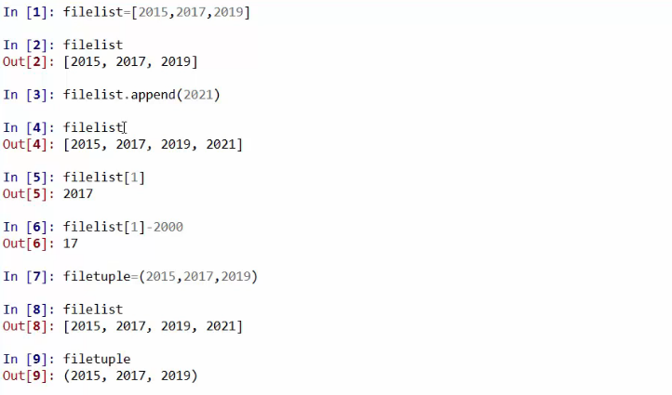

**Collections sets and dictionaries**

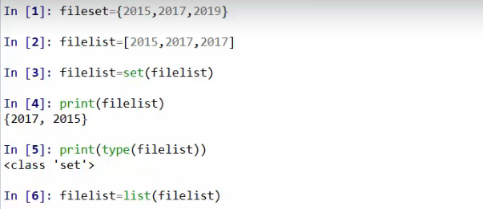

To eliminate duplicate values from list convert to set

Dictionaries

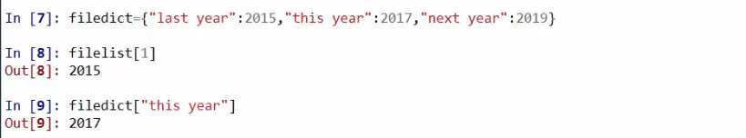

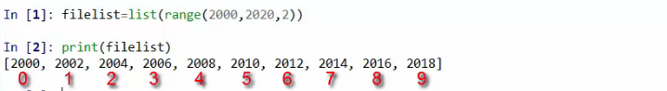

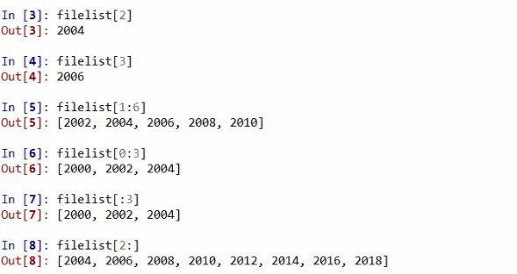





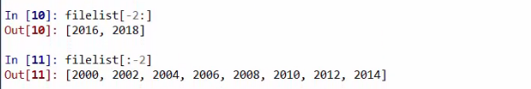

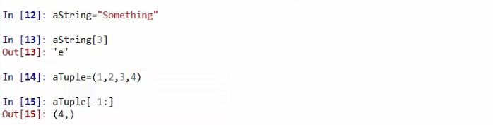

Iterating

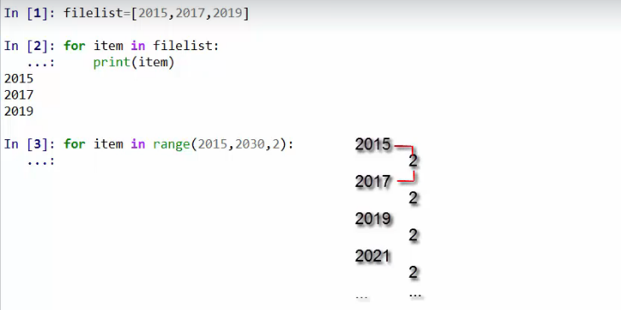

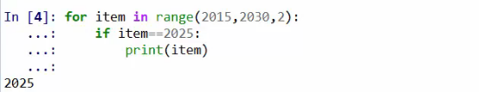

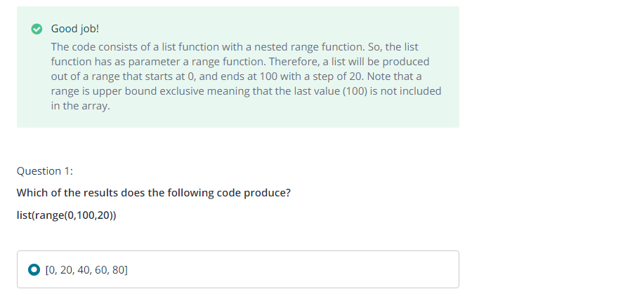

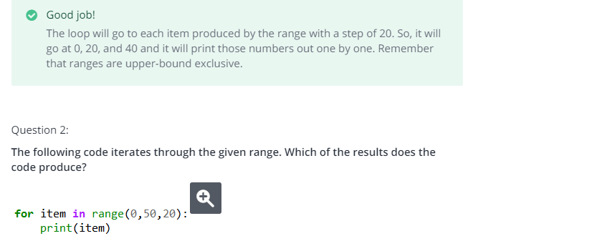

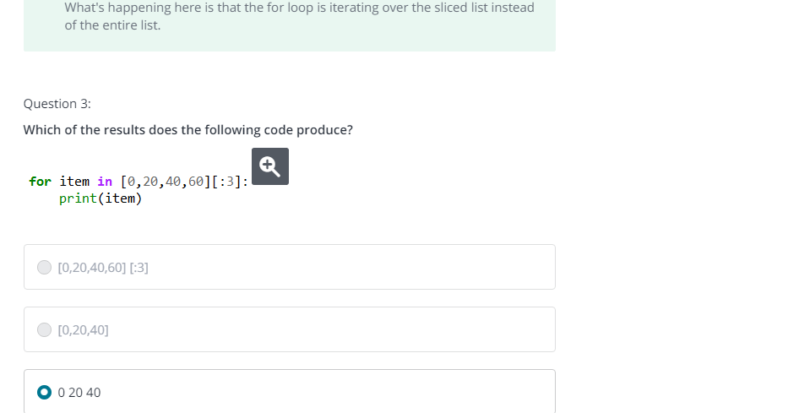

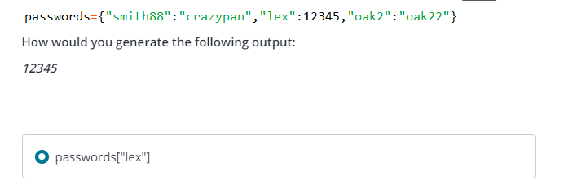

**Working with files**

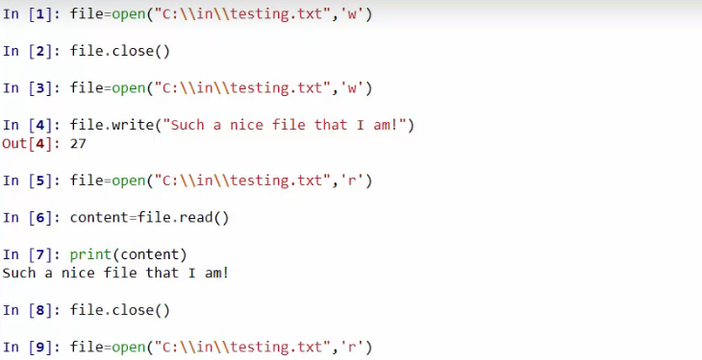 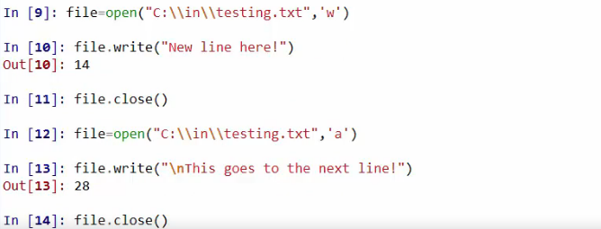

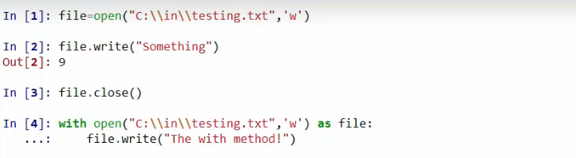

With closes the file automatically

